Pre Lab: Calibrating a Function Generator

The Fourier Transform
For a signal $x\left(t\right)$, the continuous time Fourier Transform $X\left(ω\right)$ can be found as
$$X\left(ω\right)=\int_{-∞}^{∞}{x\left(t\right)e^{-jωt}dt}$$
The Fourier Transform is a mathematical tool used to decompose a time-based signal into its individual frequency components.

Comparing Measurements

Measurement and Uncertainty: Problem 14

Part A: Problem 8 – Dice Simulation vs Perfect Distribution
For the theoretical values for a two-dice roll, the exact mean is $μ=7$ and the standard deviation is $σ=\sqrt{6}≈2.45$. Because these are theoretical, their uncertainty is 0.
In my simulation data:
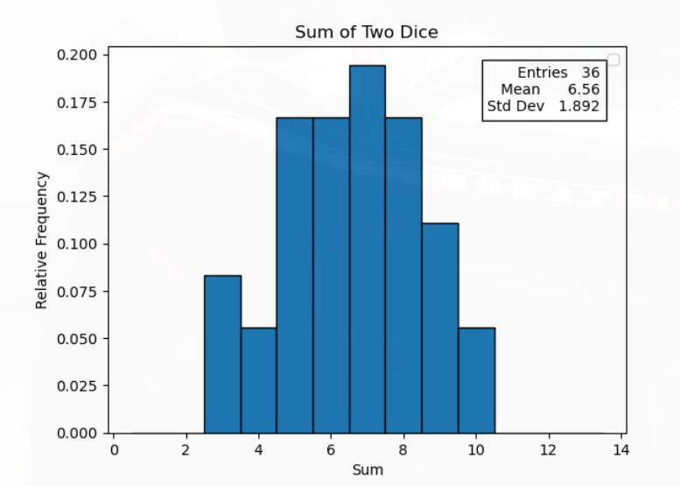
I get a mean of $\overline{x}=6.56$ and a standard deviation of $s_{x}=1.892$.

Comparing the means
The uncertainty of the simulated means is $s_{\overline{x}}=\frac{s_{x}}{\sqrt{N}}=\frac{1.892}{\sqrt{36}}=0.315$
Next, calculating the t-value for the difference between the simulated mean and the theoretical mean:
$$t_{mean}=\frac{|6.56-7|}{\sqrt{{0.315}^{2}+0^{2}}}=\frac{0.44}{0.315}=1.40$$
According to the Normal (Gaussian) probability table, a $t$-value of $1.40$ falls between $1.0$ ($68\%$ probability of difference) and $1.5$ ($87\%$ probability of difference). Because the $t$-value is relatively low, we cannot definitively say the simulated mean is significantly different from the theoretical mean.

Comparing the Standard Deviations
Calculating the fractional uncertainty of the simulated standard deviation using $N=36$
$$s_{s_{x}}=\frac{s_{x}}{\sqrt{2\left(N-2\right)}}=\frac{1.892}{\sqrt{2\left(34\right)}}≈0.229$$
Calculating the $t$-value for the standard deviations:
$$t_{std}=\frac{|1.892-2.45|}{\sqrt{{0.229}^{2}+0^{2}}}=\frac{0.558}{0.229}≈2.44$$
Referring again to the Normal probability table, a $t$-value of 2.44 inficates a roughly $98\%$ to $99\%$ probability that the difference is significant.
Conclusion: While the simulated mean matches the expectation reasonably well, the standard deviation of the simulated data is significantly tighter than the theoretical prediction.

Part B: Problem 10b – Reaction Time vs. Paper Fall Spread
Finding the differences between the standard deviation between the reaction time and paper fall experiments.

- Reaction time: $s_{1}=0.120s$ for $N_{1}=20$ trials
  - The uncertainty of $s_{1}$ is found by $u\left(s_{1}\right)=\frac{0.120}{\sqrt{2\left(18\right)}}=0.020s$
- Paper fall: $s_{2}=0.241s$ for $N_{2}=20$ trials
  - Uncertainty of $s_{2}$ is found by $u\left(s_{2}\right)=\frac{0.241}{\sqrt{2\left(18\right)}}≈0.040s$
Calculate the combined uncertainty of the difference and the resulting $t$-value:
$$t=\frac{|s_{2}-s_{1}|}{\sqrt{u{\left(s_{1}\right)}^{2}+u\left(s_{2}\right)^2}}=\frac{|0.241-0.120|}{\sqrt{{0.020}^{2}+{0.040}^{2}}}=\frac{0.121}{0.0447}≈2.71$$
Conclusion: A $t$-value of 2.71 corresponds to a >99% probability of a difference. This proves quantitively that the physical mechanics of dropping a piece of paper introduces a significantly larger statistical spread than human reaction time alone.

Problem 15: Ring Measurement and Uncertainty Propagation

- Rind Diameter $\left(D\right):$ 20.0 mm
- Circumference $\left(C\right):$62.5 mm (measured by wrapping a string, then measuring the string)

Defining the Uncertainties:
I am using an analog metric ruler with 1 mm marks. The limit of precision (half-width $a$) is 0.5 mm. Assuming a triangular PDF for reading an analog scale, the Type B uncertainty for both measurements is:

$$s_{C}=s_{D}=\frac{a}{\sqrt{6}}=\frac{0.5}{\sqrt{6}}≈0.204 mm$$

Propagating the Uncertainty of the Ratio
Finding the ratio $z=\frac{C}{D}$ evaluates to 3.125
Because the same ruler was used for both measurements, the Type B scale uncertaintis are perfectly correlated, meaning the correlation coefficient $r_{CD}=+1$.

Applying the general uncertainty propagation formula (equation 12):
$$s_{z}^{2}={\left(\frac{∂z}{∂C}\right)}^{2}s_{C}^{2}+{\left(\frac{∂z}{∂D}\right)}^{2}s_{D}^{2}+2\left(\frac{∂z}{∂C}\right)\left(\frac{∂z}{∂D}\right)r_{CD}s_{C}s_{D}$$
Calculating the sensitivity coefficients:
- $\frac{∂z}{∂C}=\frac{1}{D}=\frac{1}{20.0}=0.05 {mm}^{-1}$
- $\frac{∂z}{∂D}=-\frac{C}{D^{2}}=-\frac{62.5}{400.0}=-0.156 {mm}^{-1}$
Plug into the variance equation:
$$s_{z}^{2}={\left(0.05\right)}^{2}{\left(0.204\right)}^{2} + {\left(-0.156\right)}^{2}{\left(0.204\right)}^{2} + 2\left(0.05\right)\left(-0.156\right)\left(1\right){\left(0.204\right)}^{2}$$
$$s_{z}^{2}={\left(0.204\right)}^{2} [0.0025 + 0.0243 - 0.0156] = (0.0416) ×(0.0112) ≈0.000466$$
$$s_{z}=\sqrt{0.000466}≈0.022$$
The final Measurement for the ratio is $3.125±0.022$.

Comparison to Expectation:
The expected ratio of circumference to diameter is $π$. The significance of the difference can be checked using a $t$-test:
$$t=\frac{\left|π-z\right|}{s_{z}}=\frac{\left|3.142-3.125\right|}{0.022}=\frac{0.017}{0.022}≈0.77$$
Conclusion: A $t$-value of 0.77 indicates a roughly 50% probability of difference, which is well below the threshold for significance. Therefore, the simulated measurements agree with the geometric expectation of $π$.

Graphing Sine Waves with Python

With inputs of $f=2 Hz$ and $t=5 s$ for both
